Support Inglemoor High School’s
International Baccalaureate (IB) Program
Join the IB Booster Club!

The IB program is a community program! Every single student who takes an IB course at Inglemoor benefits from your support. Your membership supports course and exam materials for IB classrooms and funds student recognition activities. If your child is involved in the IB program, you should be a member!

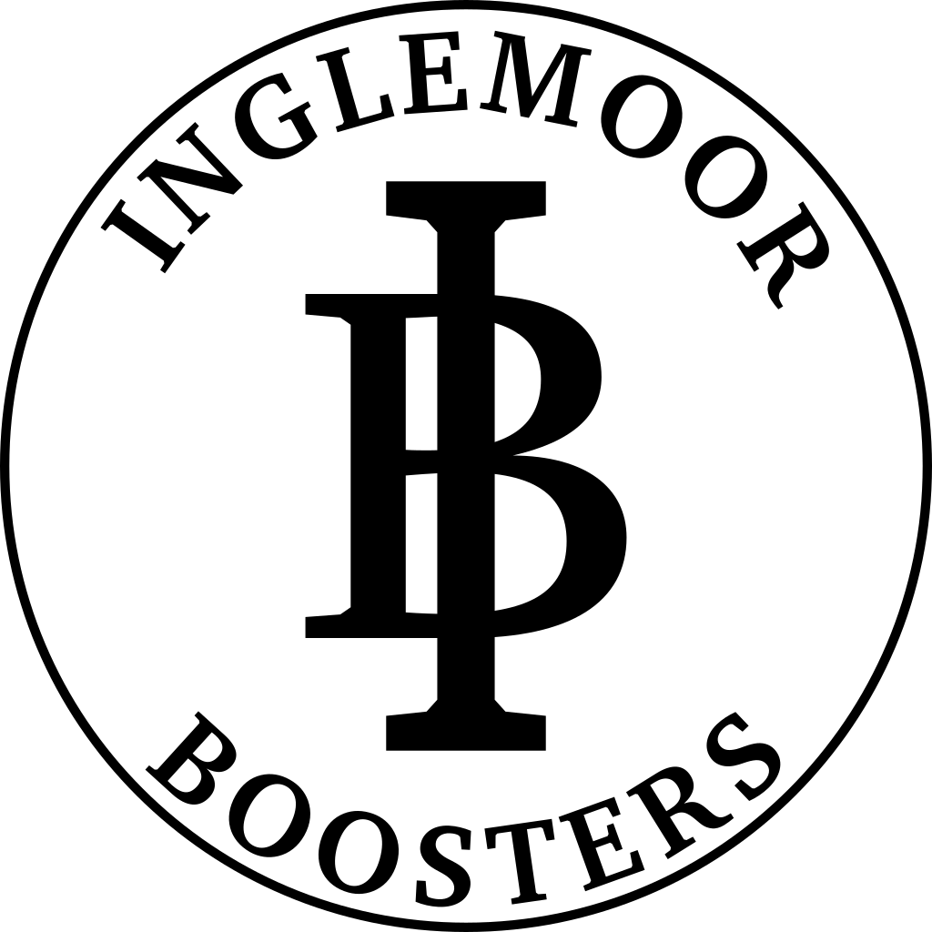
The Inglemoor IB Booster Club sustains the high quality of the IB program by providing volunteer and financial resources! Your support helps us to build a stronger program for our IB Students.

Name:_________________________________________
Email:__________________________________________
Phone:_________________________________________
Address:________________________________________
_________________________________________

ANNUAL MEMBERSHIP LEVELS
- $102 (Viking) New Membership_____________
- $52 (Gold) Renewing Membership_________
- $27 (Black)
- Other________

You may also contribute with PayPal (email address is ihsibclub@gmail.com) or Check (Payable to IB Booster Club).

STUDENT INFORMATION
- Graduating Year______
- Graduating Year______
- Graduating Year______

VOLUNTEER OPPORTUNITIES – The IB program is a community program and we need you!
I am interested in learning how I can volunteer to help the IB program:
______Proctor IB exams ______IB recognition ceremony
______CAS advisory ______General

CORPORATE MATCHING
If you think your employer participates in corporate matching/charitable gifting, check with your HR department to request a match for your donated dollars, or sign up for a payroll deductions contribution.
The organization name is Inglemoor High School International Baccalaureate Booster Club.
_______ Yes, my employer participates in a gift matching program. I can submit a request to match my donation/ payroll deduction.

Employer:__________________________________ Employee___________________________________

Donations and membership funds may be paid through PayPal or sent to:
IB Booster Club, Inglemoor High School
15500 Simonds Rd. NE Kenmore, WA 98028

The IB Booster Club is a 501(c)(3 )non-profit organization. Our tax ID number is 04-3801831. Membership contributions are tax deductible to the extent allowed by the IRS. Your cancelled check is your receipt.

Website: http://www.ihsib.org/home.html Email: ihsibclub@gmail.com

