Support Inglemoor High School’s
International Baccalaureate (IB) Program
Join the 2019-2020 IB Booster Club!

The International Baccalaureate® aims to develop inquiring, knowledgeable and caring young people who help to create a better and more peaceful world through intercultural understanding and respect.

The Inglemoor IB Boosters Club is a non-profit parent volunteer program that sustains the high quality of the Inglemoor IB program. Your support helps us build a stronger program for our IB student community.

Every student who takes an IB course at Inglemoor benefits from your membership. Donations are used to enrich the program through the purchase of supplemental course materials and funding an end-of-year recognition ceremony, whether students pursue the IB Diploma Program, the IB Certificate of Merit or take one or a few IB courses

Help support the continuing excellence of the IB program at IHS!
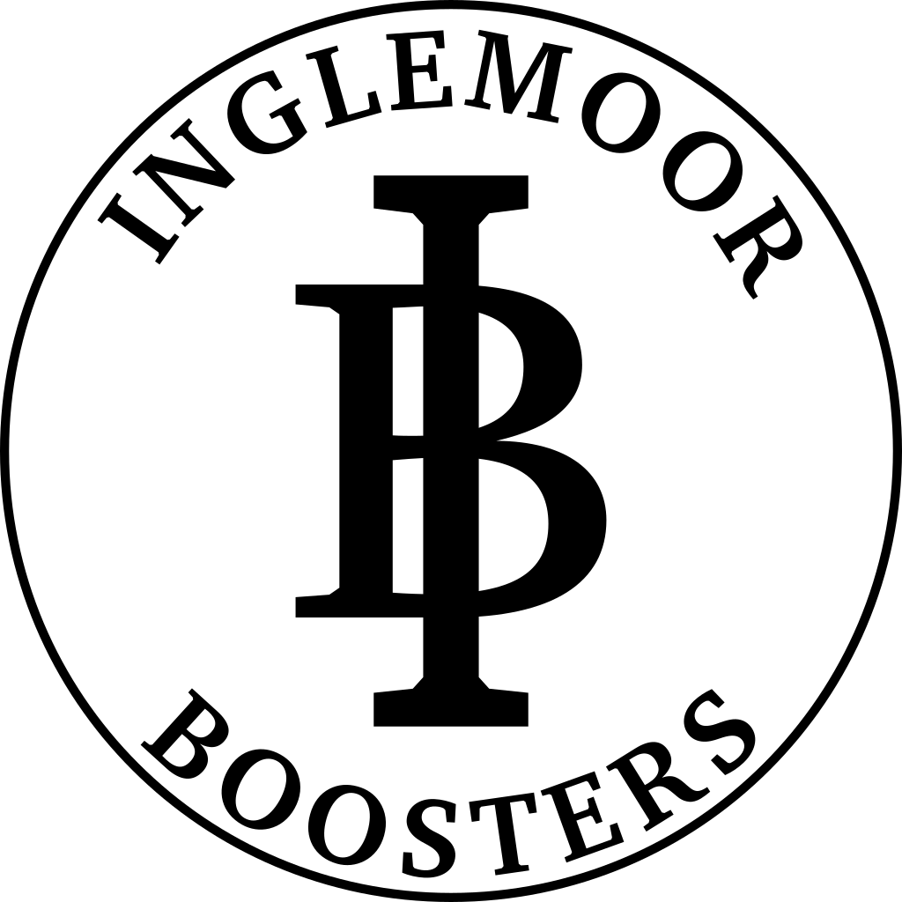
Name:_________________________________________
Email:__________________________________________
Phone:_________________________________________
Address:________________________________________
_________________________________________

ANNUAL MEMBERSHIP LEVELS
- $102 (Viking) New Membership______________
- $52 (Gold) Renewing Membership__________
- $27 (Black)
- Other________

You may also contribute with PayPal (email address is ihsibclub@gmail.com) or Check (Payable to IB Booster Club).

STUDENT INFORMATION
Name:_______________________________________________________Graduating Year______
Name:_______________________________________________________Graduating Year______

VOLUNTEER OPPORTUNITIES – The IB program is a community program and we need you!
I am interested in learning how I can volunteer to help the IB program:
______Proctor IB exams ______CAS advisory
______IB recognition ceremony ______General

CORPORATE MATCHING
If you think your employer participates in corporate matching/charitable gifting, check with your HR department to request a match for your donated dollars, or sign up for a payroll deductions contribution. The organization name is Inglemoor High School International Baccalaureate Booster Club.

_______ Yes, my employer participates in a gift matching program. I can submit a request to match my donation/payroll deduction.

Join today by returning this form to the address below, or by visiting our web site at www.ihsib.org

Donations and membership funds may be paid through PayPal to ihsibclub@gmail.com or sent to:
IB Booster Club, Inglemoor High School
15500 Simonds Rd. NE Kenmore, WA 98028

The IB Booster Club is a 501(c)(3 )non-profit organization. Our tax ID number is 04-3801831. Membership contributions are tax deductible to the extent allowed by the IRS. Your cancelled check is your receipt.

